Step One:

Objective: create a maven package in the local repository.

Software: Eclipse

1. Eclipse File – new – project

Choose Maven Project (left) ---- Use default workspace location (right)

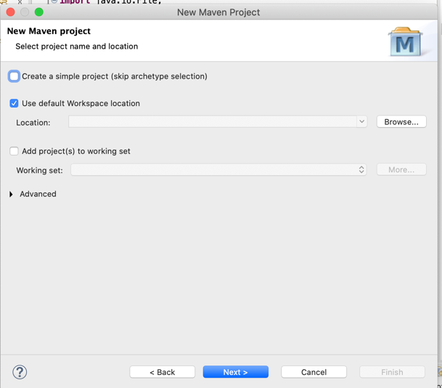

Choose maven-archetype-quickstart

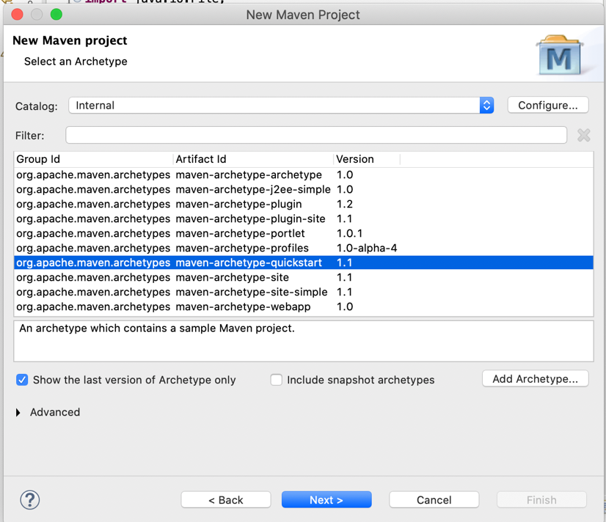

Then put in some basic information, group id and artifact id.

1. Under project in the left control panel, find App.java under src/main/java and then under Java2. Project. App.java is where you can put in the code you want (here shown is a simple default “helloworld” code.

1. Click on the project --- Run as --- 4 Maven Build

Goals: package

Then, if this is successfully run, you should see the following message:

1. (this step is not necessary for all eclipse users)
   1. Problem:

Failed to run successfully initially, and had the following message:

[ERROR] Failed to execute goal org.apache.maven.plugins:maven-compiler-plugin:3.1:compile (default-compile) on project groupproject: Compilation failure: Compilation failure:

[ERROR] Source option 5 is no longer supported. Use 7 or later.

[ERROR] Target option 5 is no longer supported. Use 7 or later.

[ERROR] -> [Help 1]

[ERROR]

[ERROR] To see the full stack trace of the errors, re-run Maven with the -e switch.

[ERROR] Re-run Maven using the -X switch to enable full debug logging.

[ERROR]

[ERROR] For more information about the errors and possible solutions, please read the following articles:

[ERROR] [Help 1] http://cwiki.apache.org/confluence/display/MAVEN/MojoFailureException

* 1. Solution:

In pom.xml, replace

<properties>

<project.build.sourceEncoding>UTF-8 </project.build.sourceEncoding>

</properties>

With

<properties>

<project.build.sourceEncoding>UTF-8</project.build.sourceEncoding>

<java.version>1.8</java.version>

<maven.compiler.source>1.8</maven.compiler.source>

<maven.compiler.target>1.8</maven.compiler.target>

</properties>

Then, you should see the build success message in step 3!

1. The last step is to turn it into a local repository.

Click on the project—run as (again) – 4 Maven build (same as before)

(different) Goals: install

Then, you should see the build success message again!

1. Lastly, run the following commands in the terminal

The “Project-0.0.1-SNAPSHOT.jar” file is the file you want to share with others!